* * * * * * * * * * P R E S S C O N F E R E N C E * * * * * * * * * * * *

What: To inform the local Southern California Asian Pacific American communities that Asian Pacific Americans, despite being the best educated group, are the most discriminated group in the workplace. S. B. Woo, executive director of 80-20 Initiative and former Lieutenant Governor of Delaware, will present the evidence of discrimination and what 80-20 plans to do in fighting for Asian-Americans. Similar press conferences are being held concurrently in major cities around the nation.

Date: Saturday, June 10, 2006

Time: 3:00 pm

Where: Golden Dragon Restaurant, 960 North Broadway, Los Angeles Chinatown, 90012 restaurant Tel. 213-626-2039

Contact: 80-20 Initiative, John Wong, Tel. 310-365-0815

Background Information:
80-20 Initiative is a national nonpartisan Political Action Committee (PAC) dedicated to working for equality and justice for all Asian Americans. www.80-20initiative.net
By nation-wide research data and irrefutable evidence, 80-20 reveals that Asian Pacific Americans have by far the lowest employment glass ceiling in America compared to every other advantaged and disadvantaged group. The work areas involved in the study includes major employment sectors, i.e. the private sector, universities, and the federal government.
The following bar chart clearly depicts the current glass ceiling situation:
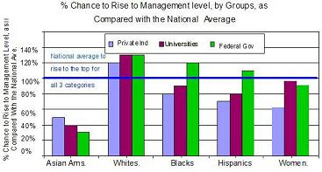

* End *

